Data Analysis using Power BI - A Superstore Retail business

ODIN School – Power BI Mandatory project

Developed by – Ramkumar Sembaiyan[S9034]

Date submitted :1 – Aug -2024

**Power BI Dashboard Design for Superstore Retail Business**

To help the new store manager better understand their data operations, we will design a comprehensive Power BI dashboard that provides valuable insights into various aspects of the superstore's performance. Here is a step-by-step approach to creating this dashboard:

**1. Importing the Dataset**

* **Step 1: Open Power BI Desktop and load the dataset by clicking on "Get Data" and selecting [Superstore_Data.xlsx](https://static.onecompiler.com/images/challenges/3zzkayhgp/Superstore_Data.xlsm).**
* **Step 2: Navigate to the file location, select the above file, and load the data into Power BI.**

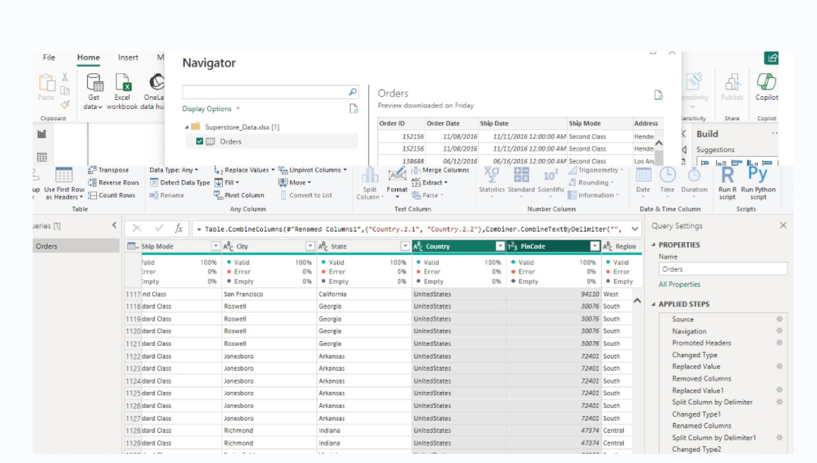

2. **Data Preparation**

* **Step 3:** In the Power Query Editor, check for any missing or erroneous data. Make sure that the data types for each column are correctly set (e.g., dates as Date, numeric values as Whole Number or Decimal, etc.).
  + **Go to the view tab, validating Column quality, the error % is 0**
  + **updating subscategory one value shows null to Art as t he product name is similar to others**
  + **Delete Column 18 as they are null column**
  + **Standardized the Ship Mode column by replacing it with First class**
  + **For easier understading the address column were split to Country, state,city using split option in transform**
* **Step 4:** Create necessary relationships between tables if the data is split into multiple sheets or tables within the Excel file.

**The only table given in the input data is ‘Orders’ table , that we consider as Fact table, to create a star schema, we need to have a few dimension(dim) table.**

**Create Dimension Tables:**

* + **In Power Query Editor, create new queries for each dimension table by duplicating the main Orders query and then removing unnecessary columns.**

**Order Details Dimension Table**

* + - **Duplicate the Orders Query:**
    - **In Power Query Editor, right-click on the Orders query and select "Duplicate."**
    - **Rename the Query:**
    - **Rename the duplicated query to "Order Details."**
    - **Remove Unnecessary Columns:**
    - **Keep only the columns related to order details: Order ID, Ship Mode, Region, and Postal Code.**
    - **Select the other columns and remove them.**
    - **Remove Duplicates:**
    - **Remove any duplicate rows to ensure each order ID is unique.**
    - **Click on "Remove Rows" -> "Remove Duplicates."**

**Customer Dimension Table**

* + - * **Duplicate the Orders Query:**
      * **Right-click on the Orders query and select "Duplicate."**
      * **Rename the Query:**
      * **Rename the duplicated query to "Customer."**
      * **Remove Unnecessary Columns:**
      * **Keep only the columns related to customer information: Customer ID, Customer Name, and Segment.**
      * **Select the other columns and remove them.**
      * **Remove Duplicates:**
      * **Remove any duplicate rows to ensure each customer ID is unique.**
      * **Click on "Remove Rows" -> "Remove Duplicates."**

**Product Dimension Table**

* + - **Duplicate the Orders Query:**
    - **Right-click on the Orders query and select "Duplicate."**
    - **Rename the Query:**
    - **Rename the duplicated query to "Product."**
    - **Remove Unnecessary Columns:**
    - **Keep only the columns related to product information: Product ID, Product Name, Category, and Sub-Category.**
    - **Select the other columns and remove them.**
    - **Remove Duplicates:**
    - **Remove any duplicate rows to ensure each product ID is unique.**
    - **Click on "Remove Rows" -> "Remove Duplicates."**
  + **Apply the changes in power query editor that will load the data into Power BI desktop**
* **Step 5:** Create necessary relationships between tables if the data is split into multiple sheets or tables within the Excel file.
  + **Create Relationships:**
  + In the Model view, create relationships between the tables:
    - **Orders Fact Table** (Order ID) -> **Order Details Dimension Table** (Order ID)
    - **Orders Fact Table** (Customer ID) -> **Customer Dimension Table** (Customer ID)
    - **Orders Fact Table** (Product ID) -> **Product Dimension Table** (Product ID)

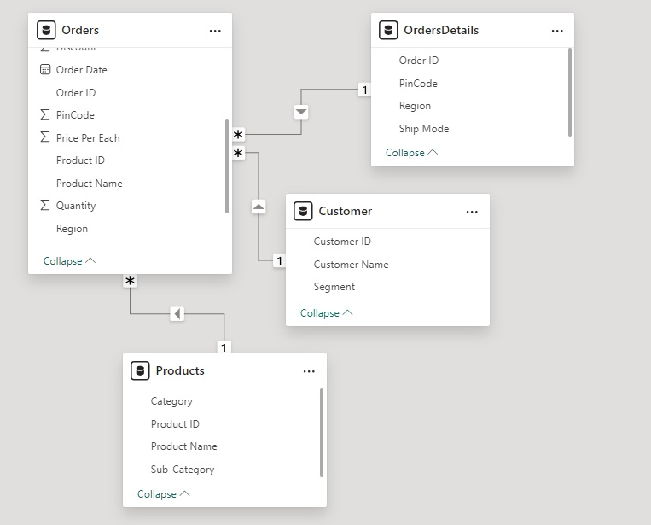

**Fact tables vs Dim tables relationship in Model View [ Cardinality is 1 to many between Dim and Fact tables.]**

3. **Creating Calculated Columns and Measures:**

**create a new column for 'Sales' (or 'Order Value') and display the total sales in a card visual in Power BI**

1. **Data View:**
   * Click on the Data icon.
   * Select the Orders table.
   * Click on "New Column."
2. **Enter DAX Formula:**

*Sales = Orders[Quantity] * Orders[Price Per Each] * (1 - Orders[Discount])*

1. **Create Card Visual:**
   * Go to the Report view.
   * Select the "Card" visual from the Visualizations pane.
   * Drag the Sales column to the Values field well.

**Visual Verification**

* **Data View:**

**Steps to Calculate Sales from Discounted Products**

1. **Create a New Column for Discounted Sales:**
   * Open Power BI Desktop.
   * Load your data if not already loaded.
2. **Add a New Column for Discounted Sales:**
   * Go to the Data view by clicking on the Data icon on the left pane.
   * Select the Orders table from the Fields pane.
   * Click on the "New Column" button in the Modeling tab.
   * Enter the following DAX formula to create the 'Discounted Sales' column:

***DiscountedSales = IF(Orders[Discount] > 0, Orders[Quantity] * Orders[Price Per Each] * (1 - Orders[Discount]), 0)***

* + Press Enter.

1. **Verify the 'Discounted Sales' Column:**
   * Ensure the new 'Discounted Sales' column appears in the Orders table with the correct calculations.
2. **Create a Card Visual to Display Total Sales from Discounted Products:**
   * Go to the Report view by clicking on the Report icon on the left pane.
   * From the Visualizations pane, select the "Card" visual.
   * Drag the DiscountedSales column from the Orders table to the Values field well of the card visual.
   * The card visual will automatically aggregate the DiscountedSales column and display the total sales value from discounted products.

"Cart Value" column in Power BI to categorize the order value/sales

**Create a New Column in Data View:**

* In Power BI Desktop, go to the Data view by clicking on the Data icon on the left pane.
* Select the Orders table.
* Click on "New Column" in the Modeling tab.

**Enter the DAX Formula:**

* Enter the following DAX formula to create the "Cart Value" column:

*Cart Value =*

*IF(Orders[Sales] < 1000, "Low",*

*IF(Orders[Sales] < 3500, "Medium",*

*IF(Orders[Sales] < 10000, "High",*

*"Very High")))*

**Press Enter:**

* Press Enter to create the new column.

**Create Measure for Total Sales from Low Cart Value:**

* Go to the Data view or Report view.
* Select the Orders table.
* Click on "New Measure."
* Enter the DAX formula:

*Total Sales Low Cart Value =*

*CALCULATE(*

*SUM(Orders[Sales]),*

*Orders[Cart Value] = "Low"*

*)*

* Press Enter.

**Create Card Visual:**

* Go to the Report view.
* Select the "Card" visual from the Visualizations pane.

Drag the Total Sales Low Cart Value measure to the Values field well of the card visual.

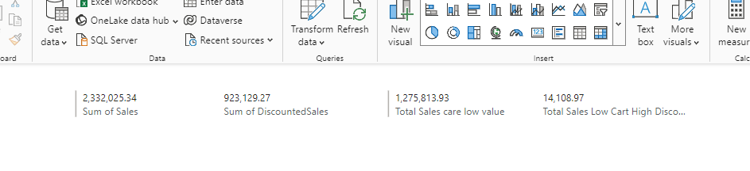

**Create Measure for Total Sales from Low Cart Value and High Discount:**

* Go to the Data view or Report view.
* Select the Orders table.
* Click on "New Measure."
* Enter the DAX formula:

*Total Sales Low Cart High Discount =*

*CALCULATE(*

*SUM(Orders[Sales]),*

*Orders[Cart Value] = "Low",*

*Orders[Discount] >= 0.5*

*)*

* Press Enter.

**Create Card Visual:**

* Go to the Report view.
* Select the "Card" visual from the Visualizations pane.
* Drag the Total Sales Low Cart High Discount measure to the Values field well of the card visual.

Calculate the Number of Days to Deliver and Create a Column Chart

**Add a New Column for Delivery Days:**

* Go to the Data view by clicking on the Data icon on the left pane.
* Select the Orders table from the Fields pane.
* Click on the "New Column" button in the Modeling tab.
* Enter the following DAX formula to create the 'Delivery Days' column:

*Delivery Days = DATEDIFF(Orders[Order Date], Orders[Ship Date], DAY)*

* Press Enter.

**Create a Measure for Average Delivery Days:**

* In Power BI Desktop, go to the Data view or Report view.
* Select the Orders table.
* Click on "New Measure" in the Modeling tab.
* Enter the following DAX formula to create a measure for the average delivery days:

*Average Delivery Days = AVERAGE(Orders[Delivery Days])*

**Create a Column Chart to Show Average Delivery Days by Shipment Type:**

* Go to the Report view by clicking on the Report icon on the left pane.
* From the Visualizations pane, select the "Clustered Column Chart" visual.
* Drag the Ship Mode field to the Axis field well.
* Drag the Average Delivery Days measure to the Values field well.

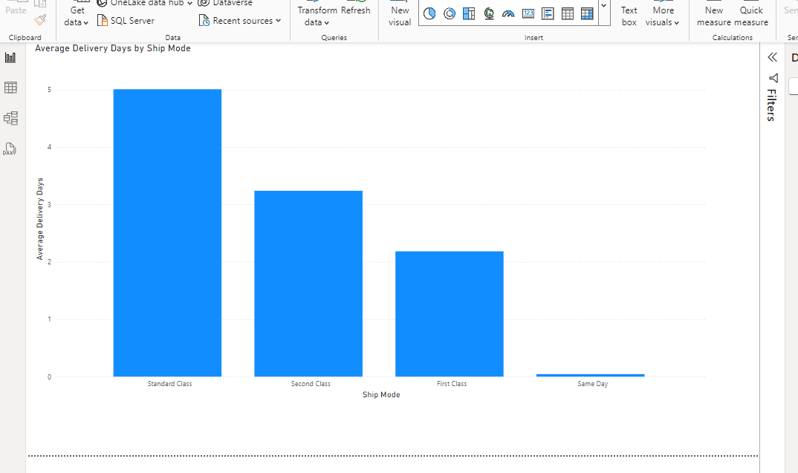

**Steps to Create the Matrix Visualization**

1. **Create Sales Measure:**
   * In the Data view or Report view, select the Orders table.
   * Click on "New Measure" in the Modeling tab.
   * Enter the following DAX formula for total sales:

*Total Sales = SUM(Orders[Sales])*

1. **Create Sales YTD Measure:**
   * Click on "New Measure" in the Modeling tab.
   * Enter the following DAX formula for sales year-to-date:

*Sales YTD = TOTALYTD(SUM(Orders[Sales]), Orders[Order Date])*

1. **Create the Matrix Visualization:**
   * Go to the Report view by clicking on the Report icon on the left pane.
   * From the Visualizations pane, select the "Matrix" visual.
   * Drag the Order Date field to the Rows field well. Power BI will automatically create a date hierarchy (Year, Quarter, Month, Day).
   * Drag the Total Sales measure to the Values field well.
   * Drag the Sales YTD measure to the Values field well.

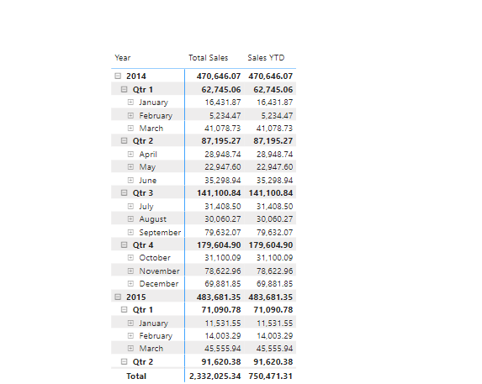

Steps to Create the Visual and Calculate YoY Growth

**Create Measures for Cumulative Sales and YoY Growth**

1. **Create a Cumulative Sales Measure:**
   * In the Data view or Report view, select the Orders table.
   * Click on "New Measure."
   * Enter the following DAX formula for cumulative sales:

*Cumulative Sales =*

*CALCULATE(*

*SUM(Orders[Sales]),*

*FILTER(*

*ALLSELECTED(Orders),*

*Orders[Order Date] <= MAX(Orders[Order Date])*

*)*

*)*

1. **Create a Total Sales Last Year Measure:**
   * Click on "New Measure."
   * Enter the following DAX formula for total sales last year:

*Total Sales Last Year =*

*CALCULATE(*

*SUM(Orders[Sales]),*

*SAMEPERIODLASTYEAR(Orders[Order Date])*

*)*

1. **Create a YoY Sales Growth Measure:**
   * Click on "New Measure."
   * Enter the following DAX formula for YoY sales growth:

*YoY Sales Growth =*

*DIVIDE(*

*[Total Sales] - [Total Sales Last Year],*

*[Total Sales Last Year]*

*)*

**2. Create the Line Chart Visualization**

1. **Create a Line Chart:**
   * Go to the Report view.
   * Select the "Line and Clustered Column Chart" visual from the Visualizations pane.
2. **Configure the Line Chart:**
   * Drag the Order Date field to the Axis field well. Power BI will create a date hierarchy.
   * Drag the Cumulative Sales measure to the Line Values field well.
   * Drag the YoY Sales Growth measure to the Column Values field well (if you want to visualize it alongside cumulative sales).

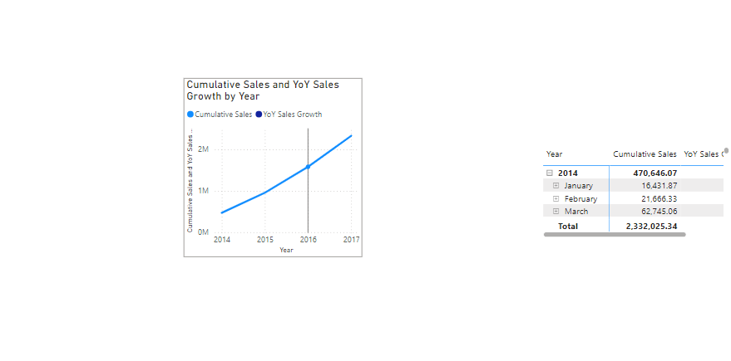

More Data Analysis reports:

